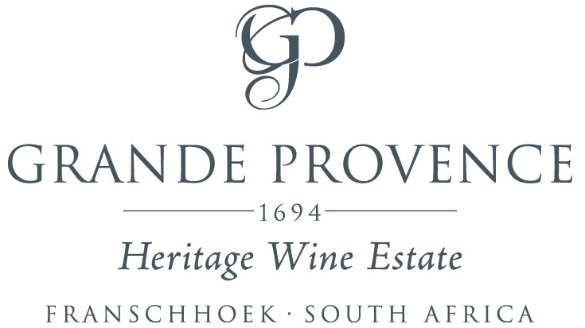

**Grande Provence Cabernet Sauvignon 2016**

**AWARDS**

**Platinum** at the South African Wine Index 2019

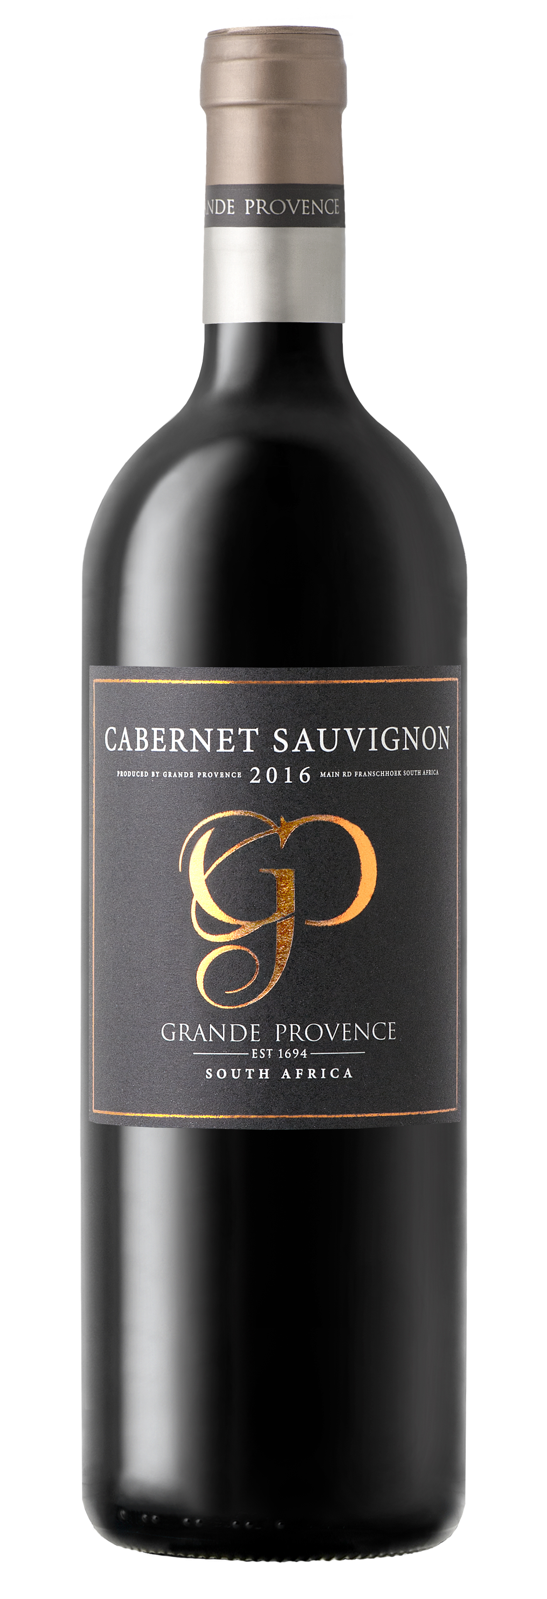 **WINE OF ORIGIN**

Franschhoek

**VINTAGE**

2016

**ANALYSIS**

Alc 14.0 vol %

pH 3.41

RS 2.7 g/l

TA 5.8 g/l

**VINIFICATION**

The Grapes are harvested from southwest facing vineyards in the Franschhoek valley. The well-drained, decomposed sandstone soils are ideal for the cultivation of Cabernet Sauvignon. The winemaker implements appropriate canopy management to achieve berries with deep colour and concentrated fruit flavours.

What makes this wine unique is the location of the vineyard next to a row of eucalyptus trees. During summer, the trees suck up all the water from the surrounding soil. High summer temperatures, cause the eucalyptus trees to ‘sweat’ through the leaves, producing a mist that is blown over the vineyard. The fine droplets landing on the grapes, impart the unique minty taste to the wine.

This wine was matured in French oak barrels for 24 months. Enjoy now or cellar for 5-8 years.

**STYLE**

Here’s a perfect medium-bodied red wine for sipping by the fireside to ward off the winter chill. The nurturing velvety tannins and elegant finish will wrap you in pure winter comfort.

This wine teems with raspberries, cherries, mulberries and plumbs with notes of fruitcake, pencil shavings and tobacco.

**SERVING SUGGESTION**

This plush red wine sips beautifully on its own or enjoy it with hearty roasts, steaks or lamb skewers bedecked in mushroom and rosemary.